**NAME: AAKASH MOHAN**

**ID: 1001656408**

**EE5353 NEURAL NETWORKS and DEEP LEARNING**

**ASSIGNMENT 7 :**

**CHARACTER RECOGNITION USING CONVOLUTIONAL NEURAL NETS using KERAS using GOOGLE COLAB**

|  |  |
| --- | --- |
|  | |
|  | # -*- coding: utf-8 -*- """Character_Recognition_for_Students.ipynb  Automatically generated by Colaboratory. |
| Original file is located at  https://colab.research.google.com/drive/1KDJ-tXKqHR5YafdcC5ajfnch3MJsZS-u  """  # -*- coding: utf-8 -*- """  Created on Thur Nov 7 14:20:37 2019  Reference from https://github.com/anujshah1003/own_data_cnn_implementation_keras/blob/mast @author: RaneChinmayAppa  """  import numpy as np import os,cv2  import glob  from sklearn.utils import shuffle  from sklearn.model_selection import train_test_split import re  from keras.utils import np_utils  import matplotlib.pyplot as plt  from keras.utils import to_categorical from keras.models import Sequential  from keras.layers import Dense, Conv2D, Flatten, MaxPooling2D, Dropout  def sorted_aphanumeric(data):  convert = lambda text: int(text) if text.isdigit() else text.lower() alphanum_key = lambda key: [ convert(c) for c in re.split('([0-9]+)', key) ] return sorted(data, key=alphanum_key)  def gen_image(arr):  two_d = (np.reshape(arr, (28, 28)) * 255).astype(np.uint8) plt.imshow(two_d, interpolation='nearest')  return plt def unique(list1):  # insert the list to the set list_set = set(list1)  # convert the set to the list unique_list = (list(list_set)) for x in unique_list:  print(x) | |

#from sklearn.cross_validation import train_test_split

from google.colab import drive drive.mount('/content/drive')

PATH = os.getcwd() # Define data path

data_path = '/content/drive/My Drive/Colab Notebooks/Character Images' # inset your path data_dir_list = sorted_aphanumeric(os.listdir(data_path)) # os.listdir(data_path)

img_rows=128 img_cols=128 num_channel=1 num_epoch=20

# Define the number of classes num_classes = 34

labels_name={'0':0,'1':1,'2':2,'3':3,'4':4,'5':5,'6':6,'7':7,'8':8,'9':9,'A':10,'B':11,'C'

img_data_list=[] labels_list = []

for dataset in data_dir_list:

img_list = glob.glob(data_path+'/'+ dataset +'/*.png')

label = labels_name[dataset] # label is generated as the library updated above for img in img_list:

input_img=cv2.imread(img,1 ) input_img=cv2.cvtColor(input_img, cv2.COLOR_BGR2GRAY) input_img_resize=cv2.resize(input_img,(28,28)) img_data_list.append(input_img_resize) labels_list.append(label)

#print(unique(labels_list)) img_data = np.array(img_data_list)

img_data = img_data.astype('float32') labels = np.array(labels_list)

#print(unique(labels)) print(np.unique(labels,return_counts=True))

Y = np_utils.to_categorical(labels, num_classes)

#Shuffle the dataset

x,y = shuffle(img_data,Y, random_state=2)

X_train, X_test, y_train, y_test = train_test_split(x, y, test_size=0.2, random_state=2) # #Normalization of the data

X train = X train / 255

X_test = X_test / 255

Nv = X_train.shape[0] Nv_test = X_test.shape[0]

#reshape data to fit model

X_train = X_train.reshape(int(Nv),28,28,1) X_test = X_test.reshape(int(Nv_test),28,28,1)

model = Sequential()

################## add model layers described in the assignment ######################

model.add(Conv2D(32, kernel_size=5, activation='relu', input_shape=(28,28,1)))

# 64 are the number of filters, kernel size is the size of the filters example 3*3 #model.add(Conv2D(32, kernel_size=5, activation='relu')) model.add(MaxPooling2D(pool_size=(3,3)))

model.add(Dropout(0.35)) model.add(Flatten()) model.add(Dense(64, activation='relu')) model.add(Dropout(0.35))

model.add(Dense(34, activation='softmax'))

########################################################################################

# 8. Compile model model.compile(loss='categorical_crossentropy',

optimizer='adam', metrics=['accuracy'])

# 9. Fit model on training data model.fit(X_train, y_train,

batch_size=32, nb_epoch=10, verbose=1) #epochs = iterations(Nit)

# 10. Evaluate model on test data

score = model.evaluate(X_test, y_test, verbose=1) print('Testing accuracy - > ',score[1] * 100)

ytested = model.predict_classes(X_test) for i in range(10):

print("The Predicted Testing image is =%s verify below" % ((list(labels_name.keys())[lis gen_image(X_test[i]).show() # printing image vs the predicted image below



Drive already mounted at /content/drive; to attempt to forcibly remount, call drive.m (array([ 0, 1, 2, 3, 4, 5, 6, 7, 8, 9, 10, 11, 12, 13, 14, 15, 16,

17, 18, 19, 20, 21, 22, 23, 24, 25, 26, 27, 28, 29, 30, 31, 32, 33]), array([5

50, 18, 50, 50, 50, 50, 50, 50, 50, 50, 50, 50, 50, 50, 50, 50, 50]))

WARNING:tensorflow:From /usr/local/lib/python3.6/dist-packages/keras/backend/tensorfl WARNING:tensorflow:From /usr/local/lib/python3.6/dist-packages/keras/backend/tensorfl WARNING:tensorflow:From /usr/local/lib/python3.6/dist-packages/keras/backend/tensorfl WARNING:tensorflow:From /usr/local/lib/python3.6/dist-packages/keras/backend/tensorfl WARNING:tensorflow:From /usr/local/lib/python3.6/dist-packages/keras/backend/tensorfl

WARNING:tensorflow:From /usr/local/lib/python3.6/dist-packages/keras/backend/tensorfl Instructions for updating:

Please use `rate` instead of `keep_prob`. Rate should be set to `rate = 1 - keep_prob WARNING:tensorflow:From /usr/local/lib/python3.6/dist-packages/keras/optimizers.py:79

WARNING:tensorflow:From /usr/local/lib/python3.6/dist-packages/keras/backend/tensorfl

WARNING:tensorflow:From /usr/local/lib/python3.6/dist-packages/tensorflow_core/python Instructions for updating:

Use tf.where in 2.0, which has the same broadcast rule as np.where

/usr/local/lib/python3.6/dist-packages/ipykernel_launcher.py:143: UserWarning: The `n WARNING:tensorflow:From /usr/local/lib/python3.6/dist-packages/keras/backend/tensorfl

WARNING:tensorflow:From /usr/local/lib/python3.6/dist-packages/keras/backend/tensorfl WARNING:tensorflow:From /usr/local/lib/python3.6/dist-packages/keras/backend/tensorfl Epoch 1/10

WARNING:tensorflow:From /usr/local/lib/python3.6/dist-packages/keras/backend/tensorfl

WARNING:tensorflow:From /usr/local/lib/python3.6/dist-packages/keras/backend/tensorfl WARNING:tensorflow:From /usr/local/lib/python3.6/dist-packages/keras/backend/tensorfl WARNING:tensorflow:From /usr/local/lib/python3.6/dist-packages/keras/backend/tensorfl WARNING:tensorflow:From /usr/local/lib/python3.6/dist-packages/keras/backend/tensorfl 1334/1334 [==============================] - 9s 7ms/step - loss: 3.1074 - acc: 0.1769

Epoch 2/10

1334/1334 [==============================] - 0s 179us/step - loss: 1.5432 - acc: 0.58

Epoch 3/10

1334/1334 [==============================] - 0s 184us/step - loss: 0.6982 - acc: 0.80

Epoch 4/10

1334/1334 [==============================] - 0s 183us/step - loss: 0.4639 - acc: 0.87

Epoch 5/10

1334/1334 [==============================] - 0s 179us/step - loss: 0.3151 - acc: 0.90

Epoch 6/10

1334/1334 [==============================] - 0s 171us/step - loss: 0.2524 - acc: 0.94

Epoch 7/10

1334/1334 [==============================] - 0s 187us/step - loss: 0.2108 - acc: 0.94

Epoch 8/10

1334/1334 [==============================] - 0s 166us/step - loss: 0.1607 - acc: 0.95

Epoch 9/10

1334/1334 [==============================] - 0s 178us/step - loss: 0.1553 - acc: 0.95

Epoch 10/10

1334/1334 [==============================] - 0s 165us/step - loss: 0.1322 - acc: 0.95

334/334 [==============================] - 0s 237us/step

Testing accuracy - > 98.20359281437125

The Predicted Testing image is =4 verify below

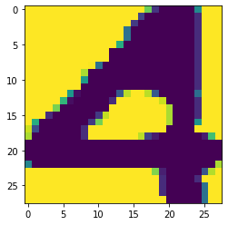

The Predicted Testing image is =R verify below

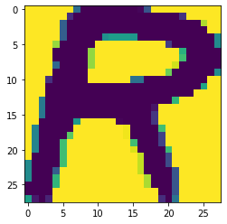

The Predicted Testing image is =M verify below

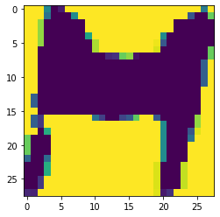

The Predicted Testing image is =R verify below

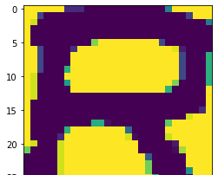

The Predicted Testing image is =K verify below

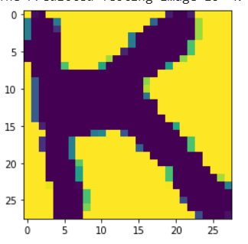

The Predicted Testing image is =G verify below

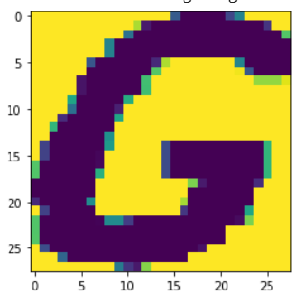

The Predicted Testing image is =Z verify below

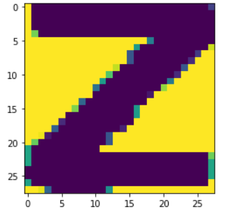

The Predicted Testing image is =5 verify below

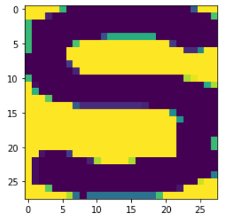

The Predicted Testing image is =N verify below

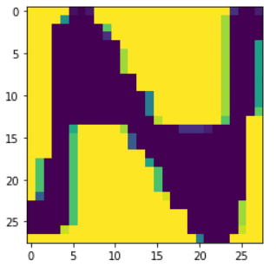

The Predicted Testing image is =1 verify below

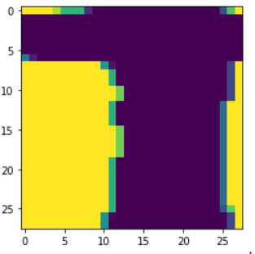

Explanation of code:

* First, we are importing the required files
* Then we use the “Lambda func” to sort the image and generate image. The lambda function is used for higher order functions.
* In generation of image we use tensor flow reshape function.
* Then we create path for importing the character file.
* Then we are creating python data structures for inputs like we are creating list and tuples.
* Then we print shuffle reshape and normalize the data.
* At the end we are calling different model layers to recognition the image.
* We are calling the convolution library file and passing 4 arguments and these arguments are “filter size, kernel size, activation function, input shape”.
* Generally, convolution layer has more than 10 arguments since we require only 4 arguments for our project, we don’t use the rest.
* Then we call the pooling library file with 1 argument and that argument is “pool size”.
* Similarly, the pooling function has 4 arguments and we use only one of those arguments.
* Then we add the dropout layer with one argument and that one argument corresponds to “rate”. The other two arguments are noise shape and seed
* Next layer that we add would be flatten with no arguments, however, flatten accepts one arguments so if we don’t specify it will by default take an argument.
* Then we add the dense layer with 2 arguments and these 2 are the “ hidden units and activation function”.
* The relu activation function is similar to that of the sigmoid function but faster.
* Similarly like the convolution and pooling layer dense also has more arguments but we only use two of those.
* We again call the dropout layer
* And finally, we call the dense layer with SoftMax activation function.
* The SoftMax function has input with tensor axis.
* Then we train and test the data for 10 epochs to recognize the image.

**CONCLUSION:**

In this assignment we run the code that is capable of recognizing the image with different model layers. These model layers are imported as a library file and are executed. We give necessary arguments to generate the and reshape the image. The image file is mentioned as a data path and then 10 epochs are executed to predict the image. The training and testing of the image are done with an Accuracy of 98.2%